Meditector:
Search Medicine by Photo with Machine Learning

Woongbi Kang
Information Systems
Hanyang University
Seoul, Korea
kgr2140@hanyang.ac.kr

Taeeui Choi
Information Systems
Hanyang University
Seoul, Korea
xodml@hanyang.ac.kr

Gunwoo Kim
Information Systems
Hanyang University
Seoul, Korea
rjsdnrrkem@hanyang.ac.kr
Minyoung Hwang
Information Systems
Hanyang University
Seoul, Korea
augreatity32@hanyang.ac.kr

Abstract—Nowadays, as kinds of medicine become more varied, consumers require more detailed information of medicine such as name, effect, or any side effects of medicine. For example, some consumers may need to avoid getting certain kinds of medicine. Based on those demands, we made an application which provides information of medicines to customers by image searching, based on machine learning.

Role Assignments
Roles | Name | Task description
Software Developer | Woongbi Kang | Make Google ML study pill data and develops Android applications based on Java and Android.
User | Taeeui Choi | Utilizes the apps and tell developers what they easy to forget or overlook and what leads user feeling dissatisfied.
Development  Manager | Minyoung Hwang | Conduct processes of development, optimize program by reflecting opinions of members, and adjust the program schedule to be completed on time.
Customer | Gunwoo Kim | Feeling that developer made this app to make something positive for customers, but the performance of this app is obviously not enough for customers. I believe this app will get better performance, and help more customers.

Keywords— medicine, pill, machine learning, image comparison, classification, customized information

Introduction
In real life, information of medicine has become more important. First, for example, if some different kinds of medicines are mixed by chance, it is obviously needed to separate medicines by related kinds of medicines. Second, consumers should be able to choose medicine. Even if it might be risky to take certain kinds of medicine arbitrarily, it would be helpful in terms of letting consumers be able to have more positive choices.
To satisfying these purposes, we made an application to identify medicines by image. With rapid growth of machine learning method, now we are able to apply machine learning method in application. We used machine learning method for image comparison to identify medicines and provide the information of it. Using this application, customers would get not only information about medicines, but also more choices in their life.

RELATED SOFTWARES
Before we start, there were some applications about providing information about medicines. ‘Smart DUR’, ‘Searching medicines’, ‘Recommendation app by using prescription and barcode’, ‘KIMS Mobile’ are similar applications in terms of searching. These applications provide information about the ingredients of the medicine, the interaction with the food, and so on. And ‘Pill Scanner’ application also has same functions, but this application’s main function is scanning medicine by photos. Based on AI, this application analyzes the medicine(photo) and shows information about the medicine.

Smart DUR
This application has these functions. First, users can search medicines they can get information about medicine, how to take drugs, and cautions about medicine. Second, applications tell whether the medicine has any problems. Lastly, if users do not know the medicine name, user can search the medicine by medicine’s shape, color, etc.
And this application saves history that users had searched. Our application also needs this function.

Medication Search
This application also give information to users about the medicines. Also, this application added the functions that telling information about diseases, and how to act he first aid method according to the situations. Uniquely this application has barcode reading function for blind people.
This application provides Korean and English when people search the medicine. And this application provides more information than related applications. So this application will be of great help in terms of information.

Pill Scanner(Beta)
Pill Scanner’s main function is searching medicine by image analyzing. This function is what we want to make mainly. Users can search the medicines by name.
But this application has weakness about searching. When search by image, it doesn’t recognize the medicine well. This application is not enough in performance, but these functions will help us for making our application.

Google ML KIT
This is a new SDK that gives mobile developers Google machine learning expertise in a powerful yet easy-to-use package on Firebase. And this program is a machine running for all skill levels. For beginners, the ML Kit provides five out-of-the-box APIs that cover common mobile use cases. There are text recognition, face detection, barcode scanning, image labeling, landmark recognition, maybe we can use text recognition technology here. ML Kit is available through Firebase, so we can easily take advantage of the larger Firebase platform.

Google OCR
This technology can be used in Google Drive, without a any installation. Upload at the google drive with the file that is end with .jpg, .png, .pdf, etc. Open these files with google docs, then users can see the photos with letters that is in photos. We can use this method with our works.

Requirements

. Splash Page
When you run an app, the app's logo or name appears briefly. After about a second, it automatically switches to the main page.

Guide Page
When the app is installed and run for the first time, it provides a brief guide to using the application, and in this case, you can only go to the main page by pressing the skip button

Main Page
The main page consists of a pill search function which are the core of this app and additional menus.
Search functions include searching through images, searching through categories, and searching through text. Users can perform searches in any way, depending on the situation.

Searching through images :
Users can either take a picture of a pill themselves or retrieve a pill picture from a gallery to find out what the pill is. This search is useful when user does not have information such as the name or ingredients of a pill and user has pictures or the substance of the pill.
Based on machine learning and pill image data, the app can identify which pill is in the entered image. To make app identify better, app highlight certain section of camera display in which medicine should be.

Searching through categories :
Users can search by category for the shape, color, form, and dividing line of the pill. This method is useful when searching through images does not produce the desired results.

Searching through text :
Users can search through text such as name, component, and identifier of the pill. This method is useful if user knows the name and ingredients of a pill.

My Page
A page to store and manage user records. If the user has previously searched for a pill, and made bookmarked, the user can select the record on this page without having to perform a new search.
Users can check their medical characteristic on the list. List includes pregnancy, heart diseases, high or low blood pressure, and etc. Based on these checks, app intends to provide customized information in the information pages.

Result Page
This page opens automatically when you perform a search on the main page. It provides search results such as a list of results and a detailed description. The results list is provided first, and users can receive detailed information about the pill when the user selects an item on the list.

List Page
If an image search is conducted, a list of results is provided based on AI image analysis. If the user takes a picture of a pill, the app compares the shape, color, and identification letters of the drug based on the data learned and provides a list of the drugs in the most accurate order.
When searching for categories, a list of pills with data matching the selected elements is provided. If user chooses the property circle and the property red, user will see a list of all the pills with the data, circle and red.
When you perform a search through text, this page provides a list of drugs that contain the text you searched for. If the user searches for the exact name of the drug, a list of drugs with similar ingredients is provided.

Detailed Page
This page provides basic and customized information for pills.

Basic information
It provides general information about pills such as name, photo, composition, and how to take them.

Customized information
The app provides customized side effects, cautions, and how to take pills based on data checked on the User Options page. For example, if users check that they are pregnant, the app will warn them if the pill contains substances that are dangerous for pregnant women or that they should be careful about.

Development Environment

Choice of software development platform

Platform
Based on Linux and Mac OS, we are going to develop application, especially run virtual machine on Windows and use Ubuntu. Android offers a robust operating system, a comprehensive set of libraries, rich multimedia user interfaces, and phone applications. The mobile phone is equipped with Andriod, which provides a variety of functions and interwork that can be applied not only to mobile phones but also to various information home appliances. Android is a mobile operating system developed by Google, based on the Linux kernel and designed primarily for touchscreen mobile devices such as smartphones and tables. There are lots of guidelines of mobile application, so our application could be built with Android studio and open source that are available for both Linux and Mac OS.

Programming language

Java
Java is an object-oriented programming language that is highly secure, simple and easy, and is most actively used in programming nowadays. Java programs could be run on most systems regardless of the type of operating system. It is efficient providing object-oriented advantages, and it is a based language in Android studio.

Python
Python has wide user range and very general programming language that can be used on a variety of platforms and it has a large library module. In addition to its function as a pure programming language, Python is often used as a glue language that links modules written in other languages.

Cost estimation
Cost for purchasing medicines to build dataset unless we fine enough amount of data. Price would be calculated later.

Detailed information of development environment.

We would like to prefer the latest version of all development environment with their reliability and usefulness. Ubuntu 18.04.1, Python 3.7.1, Java SE 11.0.1, and Tensorflow.

Software in use

Tenser flow
Tensor flow is a machine learning engine developed by Google used in Google applications such as search, voice recognition and translation. It has been distributed into open source software and used in various fields of development. It provides a python application programming interface (API).

Android studio
Android studio is an official integrated development environment (IDE) for Android. The IDE is being offered by Google for free and become popular with a fully featured Android developing environment based on stable environment. Lots of developers would like to get used and associated with Android application because of incredible growth, this tool is helping them achieve their thoughts.

Github
Github is a webhosting service that supports projects using a distributed version of the management tool, Git. Github offers both commercial and free services for open source. It provides free accounts and repositories to users, and is one of the most commonly used web hosting services worldwide for managing open source projects. It makes work comfortably providing access control and several collaboration features, such as a wikis and basic task management tools for every project. This tool will help us to co-work each other and see our own code more easily.

Task distrubution

Name | Task description
Woongbi Kang | Build Android application
Taeeui Choi | Arrange detailed description of medicine
Minyoung Hwang | Procure photo dataset of medicine for machine learning
Gunwoo Kim | Conduct machine learning with Google Tenser flow.

Specifications

Splash
When users come into our application first, show the logo of our application’s name ‘Meditector’ to let them recognize it.

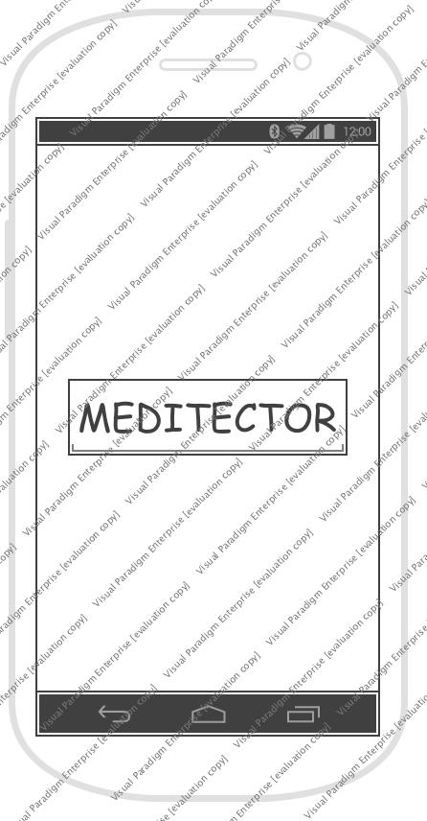

Popup guide

If it is the first time to execute the application, a guide page would be appear to user to demonstrate the usage of ‘Meditector’. There would be two buttons ‘Ok’ and ‘Never see again’.

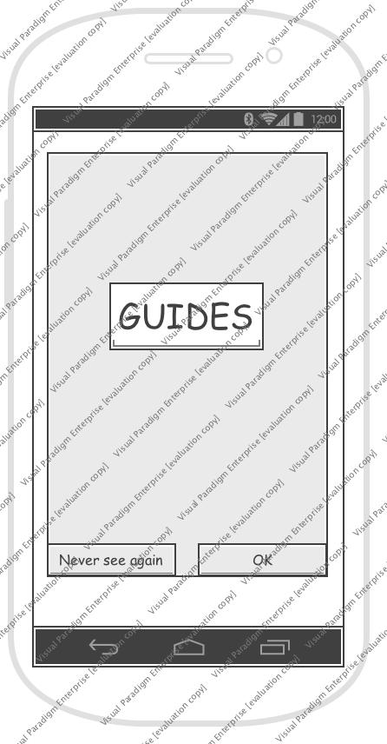

Main page
At the main page, our logo would be placed at the top, and at the middle, there are four round buttons to use functions. ‘Image’, ‘Category’, ‘Text’, and ‘My page’.

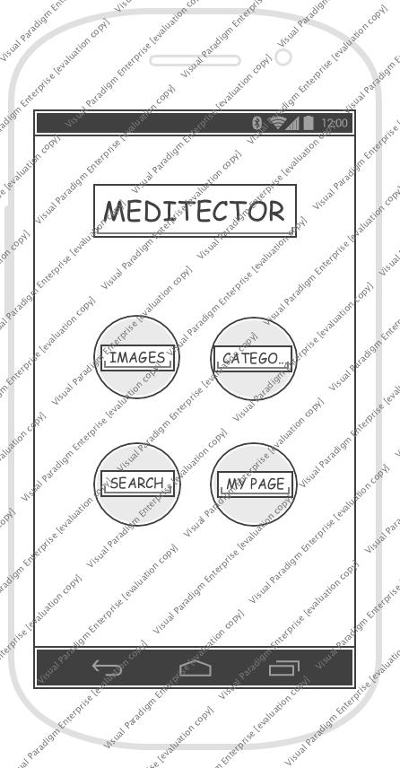

Image search
To search pill medicines with image, there would be a popup screen if a user clicks the image button. There are also two buttons ‘Camera’ and ‘Gallery’.
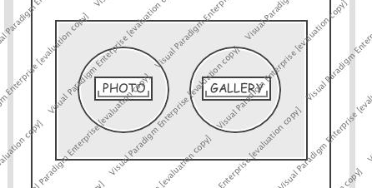

Camera
If users want to search information with photo that is taken right now, the camera in their mobile phone would be activated to take a picture. There would be a square guideline to enhance accuracy, encouraging taking a picture of a pill to be fitted inside the guideline. And a notification for guideline will be placed on top of the screen. At the bottom, there is a button for taking picture.

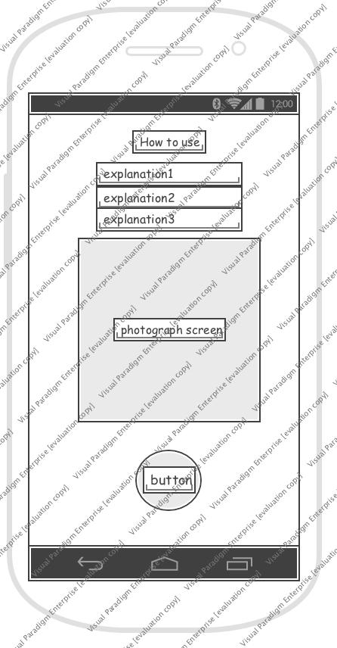

Gallery
To search information with photo that was taken a while ago, the users could bring the photo in their phone gallery application. After selecting one, they have to crop the image to make it to be fitted. So there would be a notification also.

Category search
To search with characteristics that a pill has, users could use category search. In the functionality, there will be a search button on the right side of the top, and a textbox for identification characters will be placed under that. Categories are very segmentalized such as shape, color, split line, and etc.

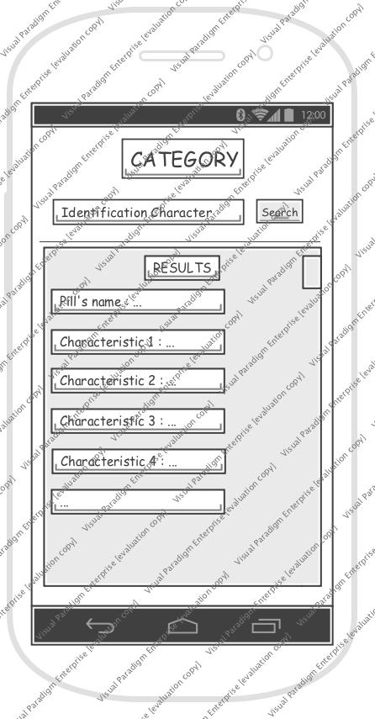

Text Search
With text, users could find information of medicines by entering the name of tablet.

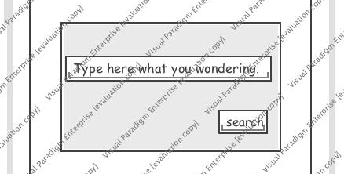

My page
In the My page section, users could set and register their own information on the application. There are two buttons ‘Bookmark’ and ‘My health’.

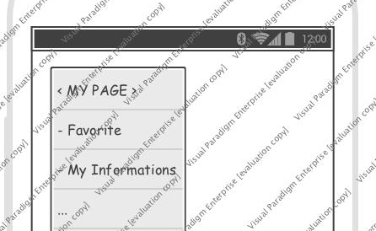

Bookmark
With bookmark function, users could make a list of pills that they frequently take or want to remember.

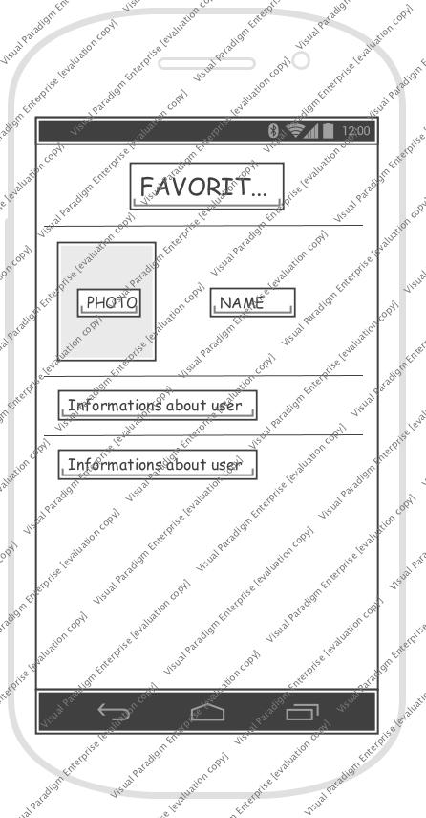

My health information
Users could register their own health information to use the function of our application that recommends or warns taking specific kinds of medicine based on their health such as pregnant and diseases.

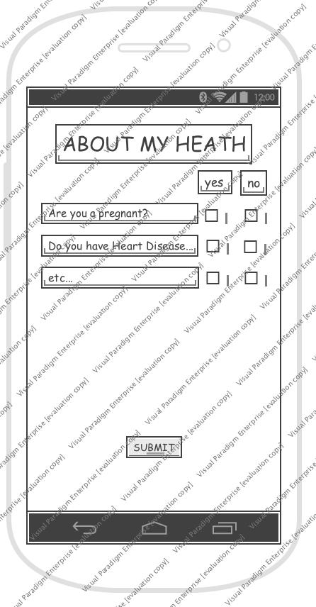

Result page

List
After searching with image or category or text, there would be a list of tablets that could possibly be a medicine that users want to find. With thumbnail images of each medicine, there are name of it.

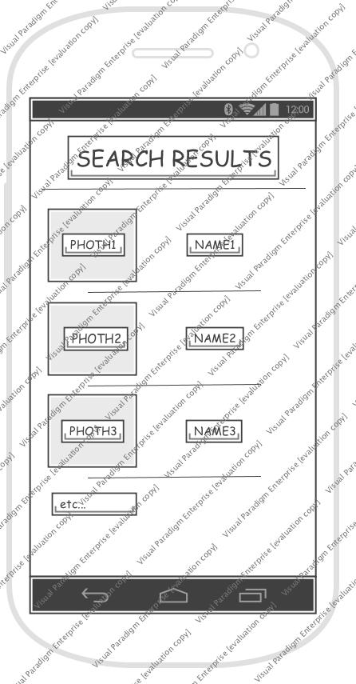

Detailed information
If users click one of the listed medicines, a detailed information of that would be shown with a new page. The name of a pill will be placed on the top, and bookmark button also on the right side. And an image would be under that, description and customized information also.

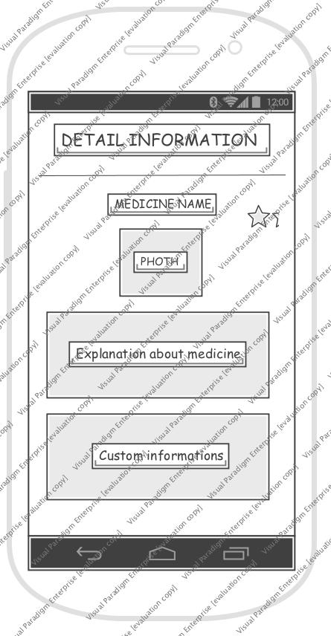

Pill Recognition with Deep Learning
For the recognition of pills in given picture, app need to have search technique which is based on deep learning method.

Region of Interest
In given picture, ROI(Region of Interest) should be caught correctly, which means to know where the pills are in picture. Without additional function, we highlight center part of camera view so users can focus on setting pills in center of the picture. This way not only gives more exact ROI, but also let users make better quality of picture. In case of pictures loaded from gallery, same thing is applied. Users can move and zoom in and out to make pills be on center of the picture.

Method and Model
We use CNN method for pill recognition with computer vision. CNN, Convolution Neural Network is most dominant method in computer vision. Among the open source model of CNN, we take the GoogleNet Inception V3 because this model has some precedent for similar tasks and has been used more commonly in other studies, which means it has lot of reference we can look for. There are three features for pill recognition in CNN : Color, Shape, Overall feature. We use three models separately.

Compatibility for Android
Not all tensorflow graphs can be used directly in Android platform. So first, make .pb file(binary) of trained model. We make two files each of trained value and graph, then integrate them into frozen graph file.

ARCHITECTURE DESIGN & IMPLEMENTATION

Overall Architecture

